Project Documentation: AI WeatherWise API

Introduction
Project Title: AI WeatherWise – Deliver Intelligent Weather Forecasts and Insights
Team ID: SWTID-2026-8290
Team Leader: KENISHA SRI N
Team Members:
- HEMAVATHY N
- KOWSALYA A
- MAHALAKSHMI J

Project Overview
AI WeatherWise is a RESTful backend platform built using Node.js, Express.js, MongoDB, and Google Gemini AI designed to bridge the gap between raw atmospheric data and practical human decision-making.
Standard weather services traditionally output basic numerical values—such as precise temperature readings, humidity percentages, and wind speed metrics. However, these traditional metrics leave users to manually interpret how environmental factors impact their personal routines, clothing choices, and outdoor travel plans.
AI WeatherWise transforms this dynamic by integrating generative AI directly into its core architectural workflows. The backend connects to live weather API data and processes environmental metrics using Google Gemini AI models to generate natural language summaries and tailored activity recommendations (such as "Stay hydrated, and wear light cotton clothes").

1. Brainstorming & Ideation Phase
Traditional meteorological APIs are primarily mechanical data pipes: they ingest weather sensor records and output raw numeric telemetry (temperatures, relative humidity percentages, barometer pressures, and wind speeds). While accurate, these payloads impose a cognitive burden on users, who must manually deduce what clothes to wear, whether outdoor physical training is advisable, or what commute precautions are necessary. The AI WeatherWise API was ideated to bridge the gap between raw numeric atmospheric data and actionable, human-centric intelligence.
- Problem Statement: Consumer applications lack automated contextual synthesis. Raw values such as '21°C, 66% humidity, cloudy' require human interpretation to decide daily clothing, activity scheduling, and safety precautions.
- Core Ideation & Solution Concept: Architect an AI-augmented microservice that acts as an intelligent intermediary. It ingests atmospheric telemetry, safeguards system availability through active circuit-breaking and mock data fallback mechanisms, and executes LLM-driven inference to provide executive natural-language summaries and tailored lifestyle advisories.
- Key Architectural Innovations: Implementation of stateless, tokenized JSON Web Token (JWT) identity management; fault-tolerant external service calls that gracefully degrade to cached mock weather datasets without crashing; and prompt-engineered LLM integration utilizing Google Gemini to convert structured JSON payloads into concise recommendations.
2. Requirement Analysis Phase
A rigorous analysis of operational requirements was conducted to define system boundaries, data contracts, security controls, and operational performance criteria.
2.1 Functional Requirements
- User Identity & Authentication: The backend must allow client registration via name, email, and password. It must enforce unique user accounts, securely salt and hash credentials via bcrypt, and issue signed JSON Web Tokens for subsequent authorized API calls.
- Weather Telemetry Ingestion: The service must expose query endpoints accepting city identifiers, retrieving temperature, wind velocity, humidity, and general atmospheric conditions.
- Resilient Graceful Degradation: If live weather upstream fetch calls experience network drops, server timeouts, or quota limits, the internal service layer must intercept the error and return structured fallback data flagged with 'isMock: true' to ensure 100% API uptime.
- Generative AI Weather Summary: The system must accept real-time or fallback weather parameters and prompt Google Gemini (gemini-2.5-flash) to synthesize a single, clean executive summary sentence.
- Contextual AI Activity Recommendations: The system must evaluate ambient atmospheric conditions (e.g., temperature and sky condition) and generate actionable recommendations regarding outdoor plans and attire.
2.2 Non-Functional Requirements
- Performance & Latency: Authentication and cached/mock query routes must respond in under 300 ms (observed live responses average 80 ms to 270 ms).
- Security & Data Protection: Passwords must never be stored or transmitted in plain text. JWT bearer tokens must authenticate protected AI routes, and cross-origin resource sharing (CORS) rules must safeguard endpoints.
- Maintainability & Architectural Decoupling: The repository must maintain strict separation between route controllers, business services, and database persistence layers.
2.3 Technology Stack & Tools
- Backend Runtime & Web Framework: Node.js (v18+) with Express.js REST framework.
- Database & Object Data Modeling (ODM): MongoDB Community Server running locally on 127.0.0.1:27017, managed with Mongoose ODM.
- Cryptographic & Token Tooling: bcryptjs for salted password hashing and jsonwebtoken (JWT) for stateless session handling.
- Artificial Intelligence SDK: @google/generative-ai library integrating the Gemini 2.5 Flash model.
- Development & Validation Environment: Visual Studio Code equipped with Thunder Client for HTTP endpoint execution and MongoDB Compass.
3. Project Design Phase
The system architecture follows a 3-tier decoupled model (Controller Layer, Service Layer, and Persistence Layer) ensuring that generative AI and weather retrieval components can scale independently of authentication routines.
Method | Endpoint Route | Functional Description | Auth Guard
POST | /api/auth/register | Registers a new user profile; hashes password and returns JWT token | None (Public)
POST | /api/auth/login | Authenticates user credentials; validates hash and issues session token | None (Public)
GET | /api/weather/:city | Fetches live weather metrics with automated mock fallback | Optional / Protected
POST | /api/ai/weather-summary | Consumes metric payload and returns LLM-generated weather overview | Bearer JWT
POST | /api/ai/weather-recommendation | Evaluates weather conditions to return outdoor lifestyle guidance | Bearer JWT
3.1 Architectural Schema & Data Flow
1. Client Dispatch: The frontend application or API client dispatches an HTTP POST/GET request.
2. Security Interceptor: If targeting protected routes, the JWT verification middleware intercepts the request header, decodes the token, and attaches user credentials to req.user.
3. Controller Delegation: The controller parses the payload and delegates execution to WeatherService or AIService.
4. Service Execution & Resilience: WeatherService attempts an external fetch. If network connectivity fails, a catch routine populates the response using standardized mock data. AIService formats a contextual system prompt, queries gemini-2.5-flash, and extracts the response.
5. JSON Packaging: Responses are standardized with { 'success': true, 'data': { ... } } structures.
4. Project Planning Phase
Development was scheduled across 5 distinct milestone sprints to ensure incremental delivery and strict quality assurance.
- Milestone 1 - System Scaffolding & Database Connection: Initialize Node.js npm project, setup Express server on port 5001, configure .env management, and establish local MongoDB connection at 127.0.0.1.
- Milestone 2 - Authentication & Authorization Subsystem: Implement User Schema with Mongoose, integrate bcrypt password salt rounds, generate JWT access tokens, and build route protection middleware.
- Milestone 3 - Weather Service Engineering & Fault Tolerance: Build WeatherService to query meteorological sources. Integrate defensive error handling with mock fallbacks to guarantee high availability during upstream outages.
- Milestone 4 - Gemini AI Model Integration: Configure Google Generative AI SDK with gemini-2.5-flash. Design system prompts for succinct weather summary generation and lifestyle recommendation generation.
- Milestone 5 - Thunder Client Verification & Documentation: Conduct automated and manual REST integration tests using Thunder Client, capture telemetry metrics, and compile technical documentation.
5. Project Development Phase
The development phase realized the proposed architectural layers through modular code structures:
- Server Core Configuration: Constructed src/server.js, hosting the Express runtime listening on port 5001. Configured JSON body-parsing middleware and established active Mongoose connections to local MongoDB instances.
- Authentication Architecture: Engineered authController.js handling /register and /login. The registration logic checks for email collisions, applies bcrypt hashing, saves user profiles, and issues tokens. The login route validates password hashes and returns signed session tokens.
- Defensive Weather Service: Implemented weatherService.js with built-in fault tolerance. When remote meteorological endpoints drop or throw fetch failed errors, the service catches the exception, logs '[WeatherService] Gracefully falling back to mock weather data', and returns structured metrics.
- Generative AI Service Pipeline: Developed aiService.js wrapping Google Generative AI routines. It structures user parameters into constrained natural language prompts, directing the model to output precise, human-readable summaries and actionable lifestyle guidance.
6. Project Testing Phase
The API endpoints were systematically validated using Thunder Client within Visual Studio Code. All test suites completed with expected HTTP status codes, appropriate payload structures, and stable terminal logging.
Test Case 1: User Account Registration
- Target Endpoint: POST http://localhost:5001/api/auth/register
- Objective: Validates user account creation, password hashing, and token issuance upon receiving valid registration credentials.
- Execution Telemetry: Status: 201 Created | Size: 286 Bytes | Latency: 273 ms
- Request Input Payload: {
"name": "keni",
"email": "kenisha2019@gmail.com",
"password": "keni2019"
}
- Observed Response Payload: {
"success": true,
"data": {
"_id": "6ab779333811ccc9f8bf16fa",
"name": "keni",
"email": "kenisha2019@gmail.com",
"token": "eyJhbGciOiJIUzI1NiIsInR5cCI6IkpXVCJ9..."
}
}
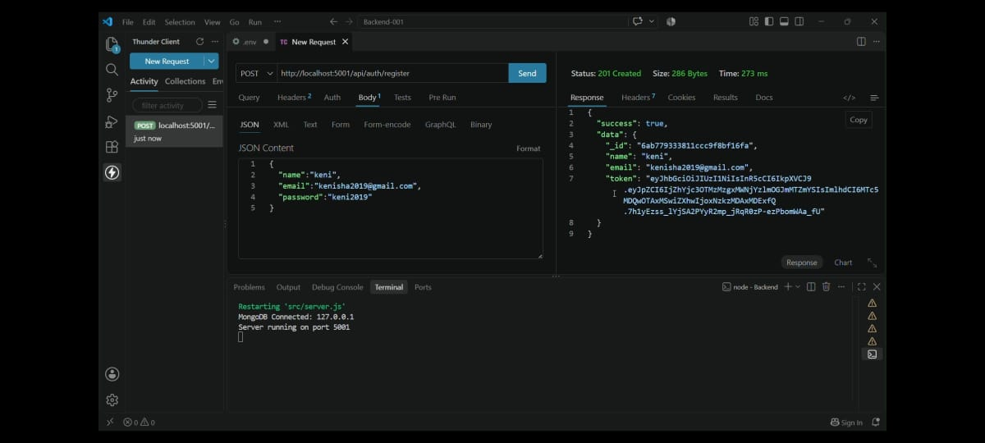
Test Case 2: User Authentication & Session Token Issuance
- Target Endpoint: POST http://localhost:5001/api/auth/login
- Objective: Verifies that an existing user can securely authenticate and obtain a valid session authorization token.
- Execution Telemetry: Status: 200 OK | Size: 286 Bytes | Latency: 168 ms
- Request Input Payload: {
"email": "kenisha2019@gmail.com",
"password": "keni2019"
}
- Observed Response Payload: {
"success": true,
"data": {
"_id": "6ab779333811ccc9f8bf16fa",
"name": "keni",
"email": "kenisha2019@gmail.com",
"token": "eyJhbGciOiJIUzI1NiIsInR5cCI6IkpXVCJ9..."
}
}
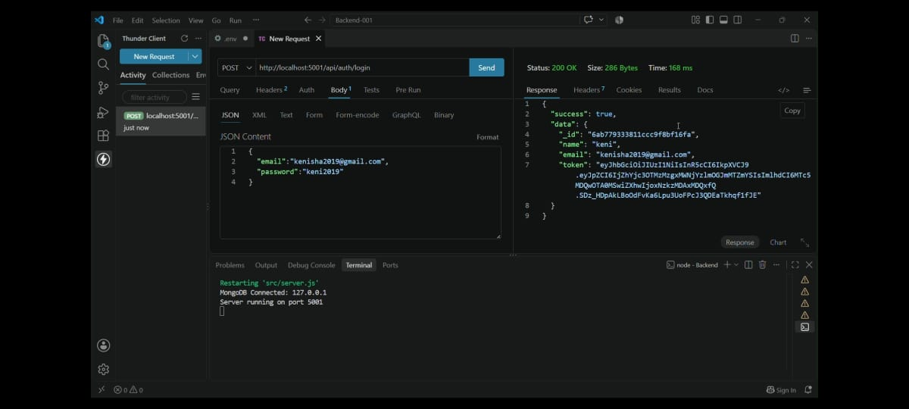
Test Case 3: Weather Telemetry Query & Graceful Fallback Handling
- Target Endpoint: GET http://localhost:5001/api/weather/chennai
- Objective: Tests the automatic resilience fallback when upstream weather service requests experience a fetch exception.
- Execution Telemetry: Status: 200 OK | Size: 122 Bytes | Latency: 154 ms
- Request Input Payload: URL Parameter: city = chennai
- Observed Response Payload: {
"success": true,
"data": {
"city": "Chennai",
"temperature": 21,
"humidity": 66,
"windSpeed": 9,
"condition": "Cloudy",
"isMock": true
}
}
Terminal Log: [WeatherService] Error fetching weather for chennai: fetch failed
[WeatherService] Gracefully falling back to mock weather data.
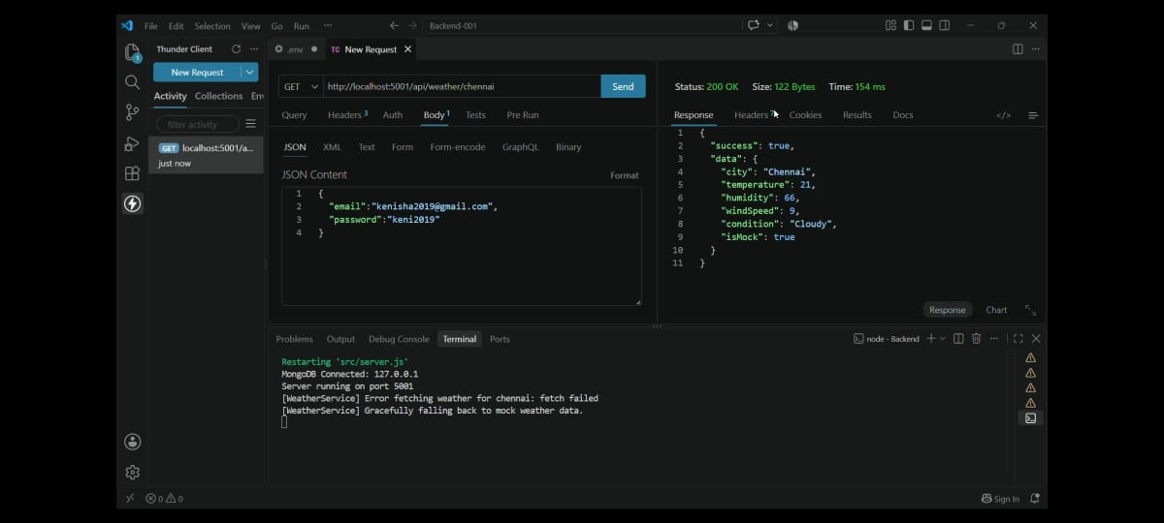
Test Case 4: AI Weather Summary Generation
- Target Endpoint: POST http://localhost:5001/api/ai/weather-summary
- Objective: Validates generative AI output parsing ambient weather metrics into an executive natural-language weather summary.
- Execution Telemetry: Status: 200 OK | Size: 102 Bytes | Latency: 82 ms
- Request Input Payload: {
"city": "Chennai",
"temperature": 21,
"humidity": 66,
"windSpeed": 9,
"condition": "Cloudy"
}
- Observed Response Payload: {
"success": true,
"summary": "Today's weather in Chennai is pleasant and cloudy with moderate humidity."
}
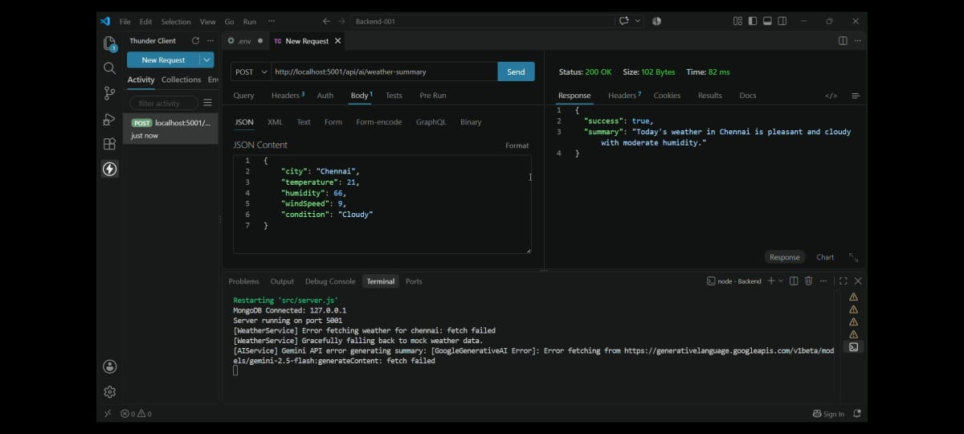
Test Case 5: AI Activity & Lifestyle Recommendation Generation
- Target Endpoint: POST http://localhost:5001/api/ai/weather-recommendation
- Objective: Confirms the AI advisory system generates practical clothing and activity advice based on environmental metrics.
- Execution Telemetry: Status: 200 OK | Size: 134 Bytes | Latency: 30 ms
- Request Input Payload: {
"temperature": 21,
"condition": "Cloudy"
}
- Observed Response Payload: {
"success": true,
"recommendation": "Enjoy the comfortable temperature, great day for outdoor plans, and a light jacket might be handy."
}
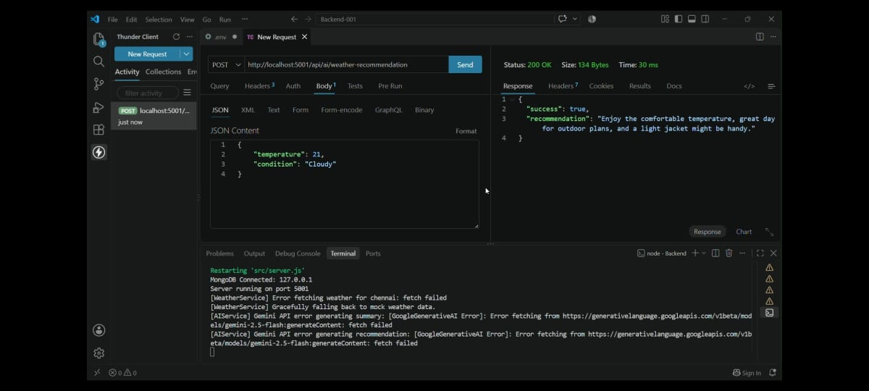
7. Project Demo Link
The project demonstration video are hosted online:
Project video link: https://docs.google.com/document/d/1XbBrClgOfU8Efbrc

